# 24 June 2016

**Miling of Chromium coated SiN membrane.**

**Parameters :**

|  |  |
| --- | --- |
| Coating | 5 nm Cr |
| Thickness | 5 + 100 nm |
| Beam | 20µm – 6.5pA |
| Dose | 1000 |
| Loop factor | 20 |
| Dot dose | 0.1004pC |
| Dot dwell time | 14.743ms |
| Design | *fptriangle* |

**Results :**

We milled a large area (triangle) of dose factor 10 that goes through the whole membrane.  
Crossing this area, we made lines of dots, each line with a higher dose factor. We then compare the dots to the hole next to them.

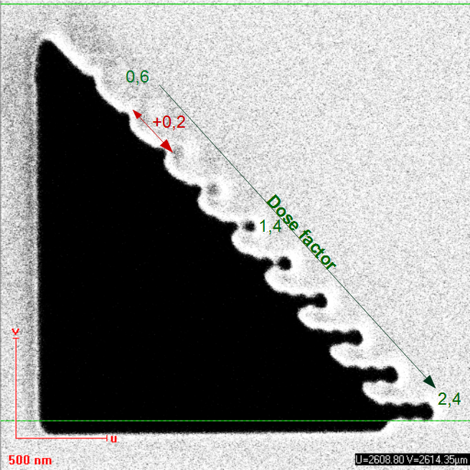

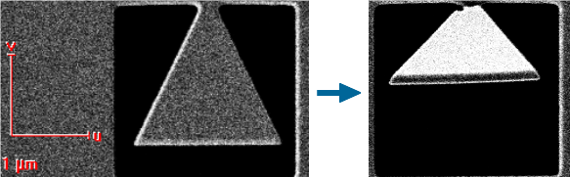The dots pierce through the membrane for a dose factor equal to **1.4** (*ie* 2.811pC). We also achieve a minimal hole size of ~70nm.  
 To make sure we milled through the membrane, we can make fall a small part of it:

Resolution?